Geospatial Anchoring of Encyclopedia Articles

Wolfgang Kienreich, Michael Granitzer, Mathias Lux
Know-Center, Competence Center for Knowledge-Based Applications and Systems
{wkien@know-center.at, mgrani@know-center.at, mlux@know-center.at}

Abstract

An encyclopedia provides a written compendium of knowledge consisting of articles concisely and exhaustively covering topics of interest. Most general encyclopedias are structured in an alphabetical manner and favor keyword queries and link-based navigation as the primary form of access. On closer examination, many encyclopedia articles can directly or indirectly be associated with geospatial references. This publication explores ways of anchoring encyclopedia articles to geospatial references and presents a web-based 3D interface which allows navigation of the German Brockhaus Encyclopedia through a geospatial metaphor.

Keywords: Encyclopaedia, Geospatial Anchoring, Visualisation, Metaphors, Web-based User Interfaces, Interactions, Browsing, GIS

1. Introduction

The World Wide Web instantly provides users with large amounts of information on almost any conceivable topic when accessed using today’s web search engines. However, much of the information available is unstructured and often unverifiable: While a web-based inquiry may yield a general idea of topics and contents in an unknown domain of knowledge, it can hardly provide the kind of trusted and concise information required, for example, in the composition of scientifc or business documents or in the preparation of educational material. Contrasting and supplementing web-based inquiry, an encyclopedia provides a written compendium of knowledge which contains articles from many different fields. Each article is prepared by domain experts and guaranteed, by the encyclopedia provider, to describe a topic exhaustively and accurately.

Most general encyclopedias are structured in an alphabetical manner and rely, in digital form, on keyword queries for locating specific articles and on link-based navigation for browsing articles. Alternative ways of access to encyclopedia knowledge bases have recently received much attention: For example, natural language query formulation has been evaluated as an alternative to keyword queries[1], and knowledge maps combining article metadata and defined inter-article relations into a unified navigation model have been proposed [2]. This publication discusses a geospatial approach to encyclopedia search and navigation. After a brief introduction to the domain of Encyclopedia systems, a description of the concept of geospatial anchoring outlines how encyclopedia knowledge spaces consisting of textual articles can be combined with named geospatial references. A prototype geographical browsing system is then presented which employs geospatial anchoring to navigate between encyclopedia articles.

2. Environment
An Encyclopedia provides a rich repository of highly structured, annotated and revised information in the form of articles covering specific topics. Today’s digital multimedia encyclopedias typically contain hundreds of thousands of articles which consist of textual content as well as images, sound and video. Information is usually reviewed and, in part, written by experts familiar with relevant knowledge areas. Digital Encyclopedias typically incorporate geographical information systems, often in the form of a world atlas providing detailed maps of terrestrial locations as well as search facilities able to locate, amongst others, political, topographical and morphological entities.

The work presented in this publication is based on the online version of the Brockhaus Encyclopedia [3], a product which enjoys a dominant market and image position in the German-speaking European countries (the famous German Duden is published by the same company). With around 240,000 articles and 350,000 mentioned keywords, Brockhaus is among the world’s largest Encyclopedias. The world atlas component of the Brockhaus Encyclopedia contains 2,000,000 named geospatial references, as well as detailed surface maps and high-precision altitude information on Moon, Mars and Earth.

3. Geospatial Anchoring
We define geospatial anchoring as the process of attaching articles from an Encyclopedia knowledge space to named geographical entities as provided by the world atlas. Anchoring of articles may occur based on various types of geospatial references made within article content. This section discusses some anchoring scenarios and challenges in identification and implementation of the anchoring.

3.1. Direct geographical references
A direct geographical reference is constituted by an article covering a topic which refers to a geographic object. For example, an article about the German capital “Berlin” should clearly be anchored to the according named geospatial object in the geographic information system. This kind of anchoring is already present in Brockhaus, and in most other encyclopedias containing geographic information systems.

3.2. Indirect geographical references
Indirect geographical references occur when within the content of an article, terms are mentioned which refer to named geospatial objects present in the geographical information system, but not necessarily within the Encyclopedia knowledge space. For example, an article about French philosopher and scientist Blaise Pascal will most certainly list his place of birth, Clermont, which, denoting a French city, appears as a named geospatial entity in the geographical information system, but which is not necessarily described by an individual encyclopedia article. A geospatial anchoring would now connect the article on Pascal to the named geospatial entity Clermont.

Geospatial anchors derived from indirect geographical references supplement the net of topical relations and explicit links between articles and enable rapid navigation between encyclopedia articles relating to named geospatial entities similar in the geographical, but not necessarily in the topical domain. Expanding the abovementioned example, users could navigate from Pascal to Clermont, from Clermont – following a geospatial relation visible only in the geographical information system – to the statue of Vercingetorix on display in the city, and from there to the History of the Roman Empire, which again would be an article in the encyclopedia domain. Proposals have already been made regarding the integration of this kind of anchoring with activities in the area of the Semantic Web [4].

3.3. Symbolic geographical references
In many cases, an article does not name a specific instance of a geographical object, but relates to a whole class of such objects. For example, an article talking about ice fields would profit from a geospatial anchoring to Greenland and Antarctica, both of which possess large ice fields. In such cases, if an appropriate geographical reference is present in the article covering the term in question, this reference can be used. For example, if the article on ice fields cites Greenland, this can be used to construct a geospatial anchor as described in section 3.2 In cases where no appropriate geographical reference is present, the geographical information system can be queried to provide an exemplary instance of the object class in question, for example returning the largest object, or the object tagged as most important by some internal ranking scheme.

3.4. Temporal spatial references
Many encyclopedia articles may refer to historical events, which usually are anchored to geographical references. For example, an article about the thirty year war would refer, among others, to Denmark from 1623 to 1629 and to Sweden from 1630 to 1635. The appropriate geospatial anchoring then has to be made in a time-dependent manner. This implies that the geographical information system supports time-based, or versioned, named geospatial entities. Temporal spatial references are exceptionally useful in analyzing more complex Encyclopedia articles: Expanding on the example above, users could navigate to Denmark in the time period given, and then look up the various reigning powers involved at the location, at that time, from the Encyclopedia.

3.5 Challenges
When trying to determine the named geospatial entities to anchor to, problems arise from ambiguities in both the encyclopedia domain and the geographical domain. For example, the Brockhaus Encyclopedia lists at least twenty named geospatial entities under the term “Berlin”. Many named geospatial entities refer to the term “Wald” (woods in German), which in turn is represented in more than one Encyclopedia articles. Such ambiguities can be resolved by using additional information present in articles (e.g. country reference, city size), and metadata present for named geospatial entities (e.g. hierarchy, class, size), to construct a context and rule out as many potential mappings as possible. In the absence of additional information, manual editing can be applied to choose the correct anchor locations.

Another problem arises when named geospatial entities change over time, or geospatial anchors are constructed for historical geographical references which may not be valid any longer. As detailed in section 3.4, the geographical information system used must support time-based, or versioned, named geospatial entities in such cases. Furthermore, data sources for the geographical information system must be created from the historical materials themselves because it is next to impossible to interpolate or track the various changes a named geospatial entity has undergone over time.[5]

4. Prototype
A web-based atlas client application has been implemented, which cooperates with the web-based version of the Brockhaus Encyclopedia and employs geospatial anchoring of Encyclopedia articles to enable browsing of Encyclopedia content by geographical context. Similar to recently published map systems like Google Earth [6] or Nasa WorldWind [7], the atlas client supports free navigation of Earth’s surface up to very high magnifications, based on satellite image and altitude data. Various dynamic map overlays provide additional geographical, morphological, political and miscellaneous information.

4.1. Functionality
The web atlas client interface is divided into three major areas (compare Figure 1, top). In the center, a map view displays the currently selected geographical context. To the right, a number of navigation controls enable users to move the viewport, to change magnification, to switch between various modes of interacting with the view and to execute functions like printing a map or copying a map to external applications. To the left, a query field enables users to search for named geographic entities. Search results are displayed in a relevance-ranked list. Clicking any item in this list produces an animated transition of the viewport from the current geographical context to that of the clicked item.

The map view initially provides users with a three-dimensional view of Earth as seen from space. Some artistic strokes, like a background star field and artificial, moving clouds have been added to enhance visual experience. The map view can be manipulated using the mouse: By default, dragging the mouse in the view will rotate Earth accordingly, and clicking a location will zoom in on that location and simultaneously center it in the view, while searching for related geographical entities in the search panel on the left side. Additional interactivity behavior can be enabled using option controls on the right side panel: A selection mode enables focusing of a selected rectangle in the view, and a measurement mode allows drawing of reference points on the map, the distance between which is then displayed in the interface. To support users in learning the various functions of the interface quickly, context and operation sensitive help messages are displayed dynamically in the map view whenever a user activates a certain function, or invokes a certain interaction, for the first time.
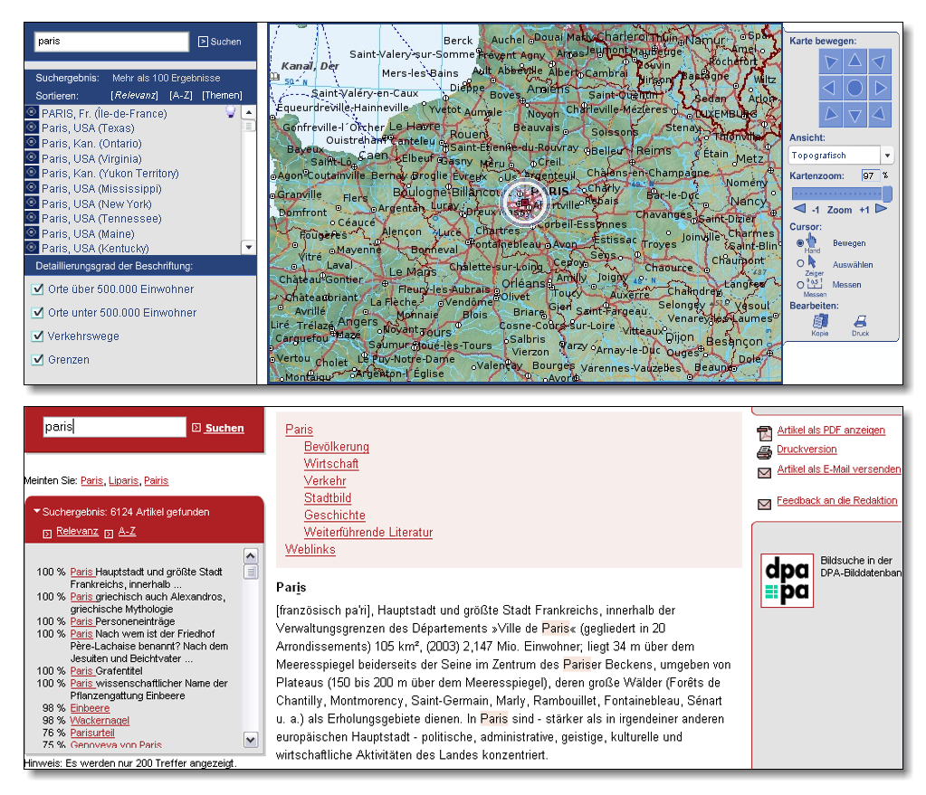
Figure 1 Map View (top), Article View (bottom)

Various types of maps can be displayed in the interface: Beside a visual map composed of satellite imagery, topological and geopolitical information is available, as well as specific information of geographic interest, like average temperature distribution or time zone boundaries. Users simply select the type of map to be displayed from a dropdown list to change the current view to a new map type. As a special case, maps of Mars and Moon are available, complete with textual descriptions of sites of interest, like crater structures on Moon or spacecraft landing sites on Mars (compare Figure 2).
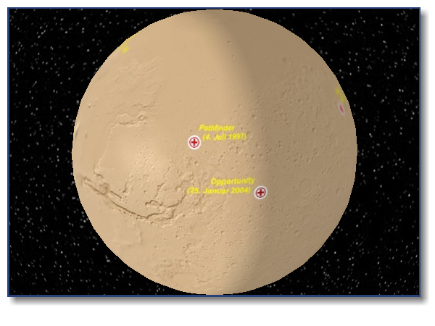
Figure 2 Mars Landing Sites

Anchoring of Encyclopedia articles to geospatial references is displayed by symbols in the list of named geographical entities on the left, and, optionally, near labels in the map view. Selecting a named geographical entity to which an article is anchored selects that article in the Encyclopedia, too (compare Figure 1, bottom), enabling users to employ the atlas view as an intermediate step in a navigation process otherwise following links or topical relations between articles.

4.2. Implementation
The atlas prototype has been implemented using a client-server architecture similar to the setup described in the MapsAlive project [8]. A server application accepts client requests for texture maps covering the whole planet, map segments specified by view coordinates and queries for named geographical entities. Communication between server and client facilitates web services. The client application has been implemented using Macromedia Shockwave 3D, a plug-in-based solution which allows in-browser display of multimedia content [9]. This technology has been preferred over considered alternatives like Java Applets or Macromedia Flash, because it provides both the ability to generate full 3D views using hardware acceleration as available on a client system and to display 2D views quickly and efficiently [10].

The generation and display of the map view on the client system follows a two layer approach: For low-resolution viewing, when a significant part of Earth is visible at once, a texture map provided by the server and cached in client memory is composited onto a geometric model of the planet using 3D rendering techniques. Texture resolution can be dynamically increased whenever load time is available or increasing magnification requires this. Because all required information is already present in client memory, and in most cases processed by dedicated graphics hardware, this first layer of rendering is very fast, allowing for real-time animated sequences. However, as magnification increases, texture resolution becomes too low for a high quality map display. At this point, the client switches its display method and starts acquiring map segments matching the current viewport from the server, which generates such segments in real-time, given coordinates and magnification specifying the viewport.

Whenever animation is required (e.g. when an animated transition is made from one location to another), the high resolution map segment currently loaded is faded out and fast texture-based rendering is employed as described above. At the end of an animation sequence, a new static map segment is requested for the new viewport location from the server. The drawback of this procedure is that, especially at high magnifications, the map view displays significantly less detail during animation. However, the fading effect applied to static map segments ameliorates the visual impact, and on the positive side, performance of animation operations is high even on older machines with less capable graphics hardware.

5. Benefits
As outlined in the examples in section 3.2, individual users benefit from the prototype described, and from geospatial anchoring in general, by gaining the ability to navigate between Encyclopedia articles through geospatial references, even if no explicit links are defined between these articles in the Encyclopedia knowledge space. Two or more users benefit further from applying the visual representation of geospatial references as a Knowledge Visualisation[11]: Heterogeneous groups of users can employ geospatial references and their visual representations as a common, comprehensive and unifying metaphor along which to communicate and share knowledge. For example, geospatial anchors can be used as signposts to relevant articles, and view ports to the visual representation can be specified as an alternative to textual queries describing a subset of articles.

6. Future Work
The web atlas prototype has been expanded into a product version and is currently available, for paying subscribers, on the Brockhaus Encyclopedia Online web pages. A major future enhancement envisioned is the integration of dynamic content provided by third parties into the geospatial reference framework. For example, news articles as delivered by news agencies could be displayed in the map view, provided they contain information enabling the derivation of a geospatial mapping. Information of a more technical nature, like network analysis data, could be visualized in this way, too [12], and would be much easier to anchor to named geospatial entities.

Another challenging research direction is the further incorporation of temporal-spatial geographic references. Encyclopedia articles of a historical nature, relating to named geospatial entities no longer existing in today’s maps, or articles relating to processes or events covering time spans as well as named geospatial entities, are currently very hard to anchor to geospatial references. The introduction of versioned or time-based geospatial entities into the geographical information systems backing the atlas application is envisioned to address this topic.

Building on the experiences in the web atlas project, we are currently working on extending the concept of geospatial mapping and navigation to the domain of Astronomy. A solar system simulator and deep space map exhibiting similar features and anchoring mechanisms as the web atlas client is currently being designed and implemented, and will be made available with future versions of the Brockhaus Encyclopedia.

Conclusions
In this publication, we have discussed geospatial anchoring of Encyclopedia articles and presented a prototype system enabling users to browse encyclopedia knowledge spaces through a geospatial metaphor. In the absence of an all-encompassing ontology able to provide total coverage navigation between encyclopedia articles by topic, alternative ways of browsing the hundreds of thousands of articles available in large encyclopedias have to be considered. Geospatial references are present in, or can be extracted from, a majority of articles, and can be integrated into easily comprehensible geographical metaphors, thus constituting a substantial enrichment for the navigation facilities of large Encyclopedias.

Acknowledgements
The Know-Center is a Competence Center funded within the Austrian Competence Centers Programme K plus under the auspices of the Austrian Ministry of Transport, Innovation and Technology (www.kplus.at).

We would like to thank Arndt Frederichs and Bernd Kreissig, both of Bibliographisches Institut & F. A. Brockhaus AG, for their feedback and efforts.

References
- Ji-Rong Wen, Jian-Yun Niew, Hong-Jiang Zhang, “Clustering User Queries of a Search Engine” Proceedings of WWW10, 10th International Conference on the Worldwide Web, ACM, Hong Kong, 2001.
- Wolfgang Kienreich and Michael Granitzer. “Visualising Knowledge Webs for Encyclopedia Articles” Proceedings of IV’05, 9th International Conference on Information Visualisation, IEEE, London, England, 2005.
- Bibliographisches Institut & F. A. Brockhaus AG, Germany, 2005. http://www.brockhaus.de
- Max J. Egenhofer. “Towards the Semantic Geospatial Web” Proceedings of GIS’02, Conference on Geographic Information Systems, ACM, McLean, USA, 2002.
- Robert F. Chavez. “Generating and reintegrating geospatial data”. In Proceedings of the 5th ACM Conference on Digital Libraries, ACM, San Antonio, USA, 2000.
- Google Earth, Internet, 2006, http://earth.google.com
- Eric Sokolowsky, Horace Mitchell and Jeff de La Beaujardiere. “NASA's Scientific Visualization Studio Image Server” Proceedings of VIS’05, IEEE Conference on Visualization, IEEE, Minneapolis, USA, 2005
- Michael Potmesil. “Maps Alive: Viewing Geospatial Information on the Worldwide Web” Proceedings of WWW6, 6th International Conference on the Worldwide Web, ACM, Santa Clara, USA, 1997.
- Macromedia, Inc., subsidiary of Adobe, Inc. Shockwave 3D, Internet, 2006. http://www.macromedia.com
- Andreas Riedl, Gernot Katzlberger, Harald Tomberger. “Entwicklungs-/Modellierumgebungen für Web-basierte Geo-Virtual Reality Applikationen - eine Gegenüberstellung”. Proceedings of CORP2002 & GeoMultimedia’02, Vienna, Austria, 2002.
- Remo A. Burkhard. "Learning from Architects: The Difference between Knowledge Visualization and Information Visualization". Proceedings of IV’04, 8th International Conference on Information Visualisation, IEEE, London, England, 2004.
- Kevin S. McCurley. “Geospatial Mapping and Navigation of the Web” Proceedings of WWW10, 10th International Conference on the Worldwide Web, ACM, Hong Kong, 2001.

